Learner and Instructor AI-Supported Assessment and Feedback Analyses
July 30, 2026

Purpose: This guide supports a technical discussion with leadership. It explains the analytic sequence, model-selection logic, formulas and notation, interpretation boundaries, anticipated questions, and the recommended reporting architecture.

Core defense statement
“The methods were selected to match each outcome’s measurement level, each sample’s size and sparsity, and the assumptions supported by the data. The two stakeholder groups were analyzed separately because they answered different instruments and support different levels of model complexity.”

How to Use This Guide
- Before the meeting: Review Sections 1, 3, and 10 for the executive narrative and key numbers.
- During technical questions: Use Sections 4–8 for formulas, model rationale, diagnostics, and prepared answers.
- When discussing deliverables: Use Section 9 to explain why the workbooks should remain separate and how to create an executive synthesis layer.

Contents
- Sixty-Second Executive Defense
- Portfolio Architecture and Inference Boundaries
- Analysis Procedure Flowcharts
- Learner Analysis: Technical Defense
- Instructor Analysis: Technical Defense
- How the Analyses Connect
- Model-Selection Framework and Diagnostic Logic
- Anticipated Questions from Leadership
- Recommendation on Combining the Workbooks
- Meeting Cheat Sheet
- Appendix A. Symbols and Denotations
- Appendix B. Formula Reference

1. Sixty-Second Executive Defense
Bottom line: Both stakeholder groups were generally favorable toward AI-supported assessment and feedback, but neither group endorsed unqualified automation. Learners associated comfort with usefulness and increasingly AI-forward preferences, while still favoring universal human review. Instructors emphasized time savings, trust, model appropriateness, and continuation, while also retaining an explicit human role.

Component | Learners | Instructors
Analytic sample | 170 for Phases 4A–4C; 169 for preferred-model analysis | 31 primary quantitative cases
Main analytic question | How do feedback experience, AI comfort, usefulness, and preferred model relate? | How do efficiency, workflow, feedback evaluation, trust, appropriateness, and continuation relate?
Strongest substantive signal | AI comfort strongly differentiates perceived usefulness; usefulness strongly differentiates implementation preference. | Time savings and perceived appropriateness are the clearest correlates of continuation.
Human oversight | 65.7% preferred universal human review; 79.9% among those with a directional preference. | 87.1% preferred a future model with an explicit human role.
Inference boundary | Cross-sectional associations; no mediation or causal inference. | Small-sample descriptive and associational evidence; no adjusted multivariable continuation model.
Recommended oral summary: “The learner analysis shows an attitudinal sequence: strong feedback experiences coexist with greater AI comfort, comfort is tightly linked to perceived usefulness, and usefulness is linked to more AI-forward preferences. The instructor analysis shows an implementation sequence: efficiency, trust, and perceived appropriateness are linked to continuation, but workflow and clarity still need refinement. Across groups, AI is viewed most favorably as a support system with visible human accountability.”

2. Portfolio Architecture and Inference Boundaries
Dimension | Learner workbook | Instructor workbook | Implication
Population/role | Learners receiving feedback | Instructors reviewing and acting on AI-supported outputs | Different stakeholder experiences; do not pool rows.
Instrument | Learner-specific ordinal attitudes and model preference | Instructor-specific operational, quality, trust, continuation, and preference items | Construct names overlap only partially.
Sample size | N = 170 | N = 31 | Different feasible model complexity.
Outcome structure | Five-category ordered outcomes and four-category nominal preference | Mostly ordinal indicators plus binary continuation | Different regression families are required.
Primary inference | Adjusted associations and predicted probabilities | Descriptive, rank-based, exact, and separate bias-reduced associations | Compare patterns, not coefficients or p-values across groups.
Inference boundary: The work is a stakeholder-specific quantitative evaluation, not a randomized experiment. The language should consistently use “associated with,” “corresponded with,” “distinguished,” or “was linked to,” rather than “caused,” “led to,” “produced,” or “mediated.”

3. Analysis Procedure Flowcharts

3.1 Learner Analysis Flow
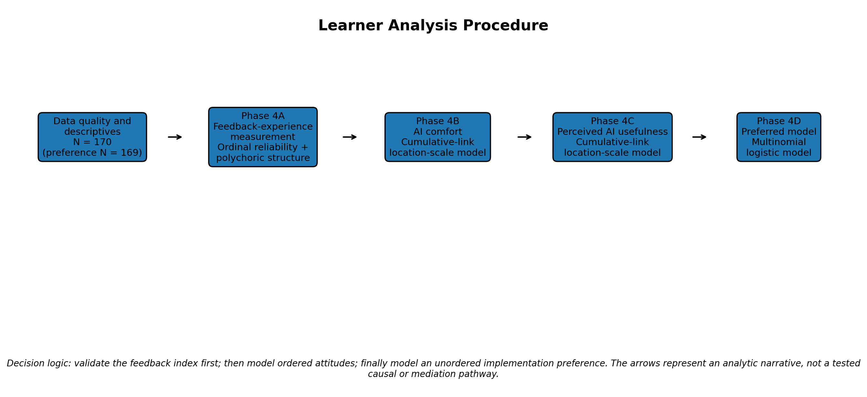
Source pathway: Learner workbook, Executive Summary, Cross-Phase Synthesis, and Phases 4A–4D.

3.2 Instructor Analysis Flow
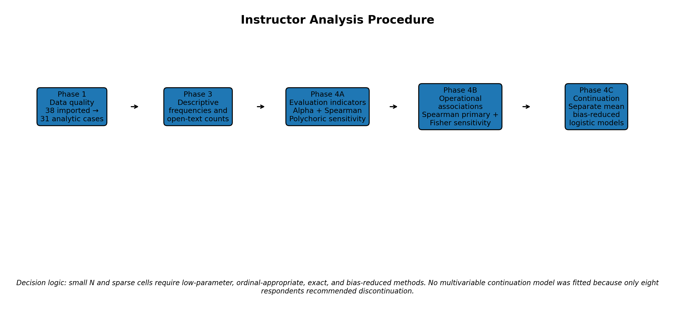
Source pathway: Instructor workbook, Phases 1, 3, 4A–4C, and Phase 6 joint display.

3.3 Recommended Cross-Stakeholder Reporting Flow
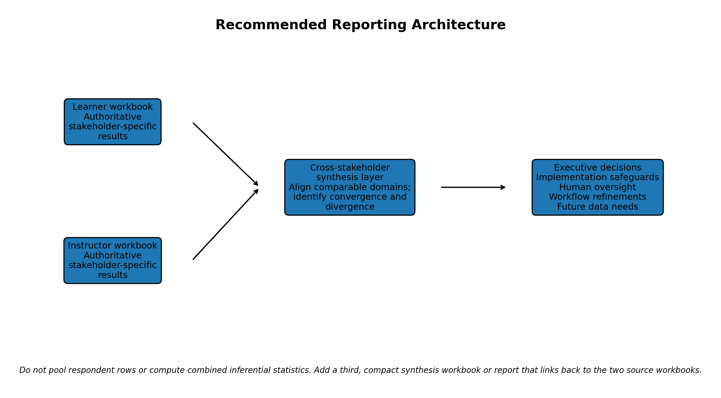

4. Learner Analysis: Technical Defense

4.1 Phase 4A — Feedback-Experience Measurement
Question answered: Can the four learner feedback items be summarized defensibly as an overall feedback-experience index before that index is used in later models?

Method and formula
- Unit-weighted index: For learner i, Fᵢ = (Xᵢ1 + Xᵢ2 + Xᵢ3 + Xᵢ4) / 4, where the four items assess rubric clarity/alignment, specificity/relevance, improvement value, and timeliness.
- Ordinal reliability: The primary reliability coefficient used the polychoric correlation matrix because the items are ordered categories rather than continuous measurements.
- Ordinal alpha: αord = k r̄poly / [1 + (k − 1) r̄poly], where k = 4 and r̄poly is the average polychoric inter-item correlation.
- Unidimensionality evidence: A dominant first component represented 78.0% of the variance in the polychoric matrix.
Evidence | Result | Defense interpretation
Ordinal alpha | 0.903 | Strong reliability for an ordinal unit-weighted index.
Average polychoric correlation | 0.701 | The items share substantial latent-response association.
Polychoric range | 0.524–0.901 | All item pairs are positive, but the items are not redundant.
Composite mean / SD | 4.80 / 0.437 | Very favorable experiences with restricted variation.
Maximum score | 71.2% | Severe ceiling effect; weak differentiation among highly positive respondents.
Four-item vs. three-item score correlation | 0.981 | The substantive respondent ordering is highly robust.

Why this method instead of alternatives?
- Why not rely only on Pearson alpha? Pearson correlations treat ordinal item categories as continuous and can understate associations when responses are highly skewed. Observed alpha was retained as a descriptive sensitivity result, but ordinal alpha was primary.
- Why not delete the timeliness item? Removing timeliness would increase ordinal alpha, but timeliness is substantively important and the four-item index already has strong reliability. Reliability maximization alone should not determine content coverage.
- Why not report CFA fit or omega? The four-item CFA was inadmissible, so CFA-based omega and global fit indices would not be defensible. The workbook correctly retains a reliable unit-weighted index without claiming a confirmed latent factor.
- Why not treat the index as highly precise? The ceiling effect means the index is useful for broad differentiation but not fine-grained discrimination among the most satisfied learners.
Q: What is the defensible one-sentence conclusion?
A: The four items support a reliable ordinal feedback-experience index with broad substantive coverage, but its severe ceiling effect limits sensitivity at the top of the scale.

4.2 Phase 4B — AI Comfort
Question answered: Which learner characteristics and experiences are associated with higher ordered levels of comfort with AI-supported feedback?

Final model
Outcome: Yᶜᵢ = AI comfort, ordered from strongly disagree to strongly agree.
Location model: ηᵢ = β₀ + β₁(prior AI experience indicators) + β₂Aᵢ + β₃F*ᵢ.
Scale model: log(σᵢ) = γ₀ + γ₁Aᵢ.
Cumulative probability: logit[P(Yᶜᵢ ≤ j)] = (τⱼ − ηᵢ) / σᵢ, for thresholds j = 1,…,4.
Coding: Aᵢ is AI awareness coded 0, 1, 2. The displayed feedback predictor is consistent with F*ᵢ = 2(Fᵢ − 4.80), so a one-unit coefficient represents a 0.5-point increase in the original feedback index.
Selection evidence | Result | Decision logic
Proportional-odds benchmark vs. awareness-scale model | Likelihood-ratio p = .034 | Allowing awareness to affect dispersion improves fit.
Linear vs. factor-coded awareness in scale model | Likelihood-ratio p = .947 | The linear 0–2 scale is sufficient and more parsimonious.
Selected model fit | AIC = 406.33; BIC = 437.69 | Use the simpler model that addresses the supported scale effect.
Presentation choice | Adjusted probabilities with 95% CIs | A single odds ratio is incomplete when awareness affects both location and scale.
Effect | Estimate | Meaning
Extensive prior AI experience vs. no experience | Location β = 4.81; p = .015 | Extensive prior exposure is associated with higher latent comfort, with a large but imprecise coefficient.
AI awareness | Location β = 1.35; p < .001 | Greater awareness is associated with higher comfort.
Feedback experience | β = 0.669 per 0.5 point; p = .008 | More favorable feedback experience is associated with higher comfort.
AI awareness scale effect | γ = 0.258; p = .031 | The spread of the latent comfort response also changes across awareness levels.
Adjusted agreement probability | 48.6% → 71.8% → 82.2% | Predicted comfort rises across not aware, somewhat aware, and fully aware groups.
- Why not ordinary least squares? AI comfort is a five-category ordered response. OLS assumes equal spacing and constant residual variance and can yield predictions outside the valid range.
- Why not binary logistic regression? Dichotomizing comfort would discard information and make the result depend on an arbitrary cut point.
- Why not standard proportional odds only? The data supported a nonconstant scale component for awareness; the location-scale model relaxes that assumption directly.
- Why emphasize probabilities? Probabilities translate a nonlinear model into the chance of an interpretable outcome, such as “somewhat or strongly agree.”

4.3 Phase 4C — Perceived AI Usefulness
Question answered: After accounting for background AI exposure and awareness, how strongly is AI comfort associated with believing AI-generated feedback can be as useful as human feedback?

Location model: ηᵢ = β₀ + β₁(prior AI experience indicators) + β₂Aᵢ + β₃Cᵢ.
Scale model: log(σᵢ) = γ₀ + γ₁Cᵢ.
Ordinal cumulative model: logit[P(Yᵁᵢ ≤ j)] = (τⱼ − ηᵢ) / σᵢ.
Selection question | Evidence | Decision
Does the location-scale form improve over proportional odds? | AIC 359.23 vs. 365.34; LRT p = .004 | Retain comfort in both location and scale components.
Does feedback experience add explanatory value after comfort? | LRT p = .917 | Exclude feedback experience from the final model.
How should the result be communicated? | Adjusted agreement probability = 1.1% to 90.4% across comfort levels | Use probabilities as the primary effect-size display.
Key result | Estimate | Interpretation
Observed agreement | 117/170 = 68.8% | A majority viewed AI-generated feedback as potentially comparable in usefulness to human feedback.
Comfort location effect | β = 3.68; p < .001 | Higher comfort is strongly associated with higher usefulness ratings.
Comfort scale effect | γ = 0.272; p = .005 | The distributional spread changes across comfort levels.
Adjusted agreement | 1.1%, 9.6%, 41.8%, 78.7%, 90.4% | A strong monotonic probability gradient appears across the five comfort levels.
Q: Why is feedback experience absent from the final usefulness model if it mattered for comfort?
A: Because model selection is outcome-specific. Feedback experience was associated with comfort, but once comfort entered the usefulness model, feedback experience provided essentially no additional fit (LRT p = .917). That pattern is consistent with comfort being more proximal to usefulness, but it does not prove mediation.

4.4 Phase 4D — Preferred Feedback Model
Question answered: How do perceived AI usefulness and feedback experience distinguish among qualitatively different preferred implementation models?

Reference category: Human-led grading with AI support.
Model for category k: log[P(Mᵢ = k) / P(Mᵢ = reference)] = αₖ + β₁ₖUᵢ + β₂ₖF*ᵢ.
Probability transformation: P(Mᵢ = k) = exp(ηᵢₖ) / [1 + Σₕ exp(ηᵢₕ)], with the reference category represented by the denominator’s 1.
Relative risk ratio: RRR = exp(β); it is the multiplicative change in the relative probability of category k versus the reference for a one-unit predictor increase.
Why multinomial? | Defense
The categories are not safely ordered | They differ simultaneously in who initiates feedback, how much AI leads, and whether human review is universal or dispute-triggered. “No preference” is also not an ordinal midpoint.
Why not collapse into AI-forward vs. human-led only? | The four-category model preserves meaningful policy distinctions. Grouped probabilities were computed afterward for communication, not as the primary outcome model.
Why this predictor set? | Usefulness and feedback experience both improved nested model fit, while more complex background-adjusted candidates had worse information criteria and less stability.
Selection evidence | Result | Interpretation
Usefulness added to feedback-only model | LRT χ² = 37.22, df = 3, p < .001 | Usefulness strongly distinguishes preferred models.
Feedback added to usefulness-only model | LRT χ² = 11.35, df = 3, p = .010 | Feedback experience contributes to overall model fit.
Final model | Log likelihood = −197.78; AIC = 413.56; BIC = 441.73 | Parsimonious two-predictor multinomial model.
Bias-reduced sensitivity | RRRs were broadly similar; largest RRR change ≈ 20.6% | Main pattern is not driven entirely by maximum-likelihood small-cell bias.
Comparison vs. human-led grading | Usefulness RRR | Interpretation
AI initial feedback + universal human review | 2.14 (95% CI 1.42–3.23) | Each one-level increase in usefulness more than doubles the relative probability of this model versus human-led grading.
AI-led feedback + disputed-only human review | 5.19 (95% CI 2.36–11.38) | Usefulness is especially strongly associated with the most AI-forward directional model.
No preference | 1.22 (95% CI 0.84–1.79) | No clear category-specific association.
Substantive result: The adjusted probability of an AI-forward model increased from 6.0% among those who strongly disagreed that AI feedback could be as useful as human feedback to 65.0% among those who strongly agreed. At the same time, 65.7% of all learners preferred universal human review. Usefulness affects implementation preference, but perceived usefulness is not equivalent to support for unrestricted automation.

5. Instructor Analysis: Technical Defense

5.1 Phases 1 and 3 — Quality Control and Descriptive Foundation
- Sample construction: 38 response rows were imported; 32 were marked complete; one completed row contained blank survey answers; one substantive partial response was retained where appropriate; the primary quantitative analytic sample was 31.
- Closed-ended completeness: All 31 analytic cases had complete data on the principal closed-ended variables. Missingness was concentrated in conditional or optional open-text items.
- Why start descriptively? With N = 31, percentages and distributions are essential for understanding sparse categories before inferential modeling.
Headline indicator | Percent
Some or significant time savings | 74.2%
Positive workflow fit | 51.6%
Positive rubric alignment | 77.4%
Clear/specific/constructive feedback | 64.5%
Good/excellent score accuracy | 71.0%
Positive trust in AI scores | 87.1%
Current model appropriate | 71.0%
Recommend continuation | 74.2%
Prefer explicit human role | 87.1%

5.2 Phase 4A — Evaluation Indicators and Measurement Caution
Question answered: Do alignment, clarity, score accuracy, and score trust behave as one coherent scale, or should they remain related but distinct evaluation dimensions?

Standardized alpha formula: αstd = k r̄ / [1 + (k − 1)r̄].
Spearman association: ρs = cor[rank(X), rank(Y)], with ties handled by the statistical software.
Evidence | Result |  | Decision
Standardized alpha | 0.649 |  | Modest internal consistency; insufficient for treating all four items as a primary unified construct.
Average inter-item correlation | 0.317 |  | Related but not interchangeable dimensions.
Primary association method | Spearman rank correlations |  | Appropriate for ordinal indicators and N = 31.
Polychoric matrix | Sensitivity only |  | Sparse cells, six zero-frequency cells requiring correction, and unequal response categories reduce stability.
Composite index | Exploratory sensitivity only |  | Do not lead reporting with a single instructor evaluation score.
Pair | Spearman ρ | BH-adjusted p |  | Interpretation
Rubric alignment–feedback clarity | 0.557 | .005 |  | Better alignment tends to co-occur with clearer feedback.
Score accuracy–score trust | 0.544 | .005 |  | Accuracy perceptions and trust are closely connected.
Clarity–accuracy | 0.418 | .034 |  | Moderate positive association.
Clarity–trust | 0.408 | .034 |  | Moderate positive association.
Alignment–trust | 0.145 | .435 |  | Little evidence of a direct monotonic relationship.
Q: Why did the learner scale become a primary composite while the instructor scale did not?
A: The learner items showed strong ordinal reliability (0.903) and dominant common structure, whereas the instructor items showed only modest standardized alpha (0.649), sparse cells, and unequal response options. The same substantive label does not justify the same measurement decision when empirical quality differs.

5.3 Phase 4B — Operational Associations
Question answered: Which operational experiences are most closely associated with perceived appropriateness, workflow fit, trust, and human-oversight preference?

Association | Spearman ρ | BH-adjusted p | Meaning
Time savings–model appropriateness | 0.630 | .001 | The strongest operational association; efficiency is closely linked to acceptance.
Trust–model appropriateness | 0.566 | .003 | Trust is closely linked to whether the current model is viewed as appropriate.
Time savings–workflow fit | 0.547 | .003 | Efficiency and workflow integration move together.
Time savings–trust | 0.492 | .009 | Perceived efficiency is positively related to trust.
Review time–time savings | −0.466 | .012 | Longer review time corresponds with lower perceived time savings.
Appropriateness–human oversight | −0.381 | .058 | Suggestive inverse relationship; not conventionally significant after BH correction.
Benjamini–Hochberg adjustment: For m tested hypotheses, order p-values p(1) ≤ … ≤ p(m), then compute adjusted values using min over j ≥ i of (m/j)p(j). This controls the expected false-discovery rate rather than the probability of any false positive.
- Why Spearman? The variables are ordinal, sample size is small, and monotonic relationships are substantively plausible without assuming equal category spacing or normality.
- Why BH adjustment? Seven operational correlations were evaluated. BH reduces false-positive risk while retaining more power than a familywise Bonferroni correction.
- Why Fisher exact tests only as sensitivity analyses? Fisher is appropriate for sparse 2×2 tables, but dichotomizing ordinal predictors discards information and makes results cut-point dependent.
Fisher sensitivity predictor | Exact OR | BH-adjusted p | Interpretation
Positive model appropriateness | 55.17 | .0004 | Very strong association with continuation; wide interval due small cells.
Perceived time saving | 25.76 | .0018 | Strong positive association with continuation.
Positive trust | 11.76 | .058 | Suggestive after multiplicity adjustment.
Positive workflow fit | 4.43 | .113 | Directionally positive but imprecise.

5.4 Phase 4C — Separate Mean Bias-Reduced Continuation Models
Question answered: How does each major implementation indicator, considered separately, relate to the odds of recommending continuation?

Binary logistic model for each predictor: logit[P(Cᵢ = 1)] = α + βXᵢ, where Cᵢ = 1 indicates continuation and OR = exp(β).
Mean bias reduction: Estimates solve adjusted score equations U*(β) = U(β) + A(β) = 0. For logistic regression, this corresponds to a Jeffreys-prior penalized likelihood ℓ*(β) = ℓ(β) + ½ log|I(β)|, which reduces small-sample bias and separation problems.
Predictor (separate model) | OR per one-category increase | 95% CI | BH-adjusted p
Perceived time impact | 11.66 | 1.93–70.61 | .013
Workflow fit | 2.40 | 0.88–6.53 | .086
Score trust | 5.07 | 1.02–25.25 | .060
Current-model appropriateness | 10.24 | 2.00–52.43 | .013
AI evaluation index (0.10-unit increase) | 3.58 | 1.43–8.96 | .013
- Why bias reduction? Only eight instructors recommended discontinuation. Conventional maximum-likelihood logistic estimates can be severely biased or infinite under sparse separation.
- Why separate models? A multivariable model with only eight discontinuation cases would be overparameterized, unstable, and hard to defend. Each row is therefore a separate association, not an adjusted independent effect.
- Why retain the evaluation index only as sensitivity? Its alpha was modest. A significant composite association does not override the measurement caution established in Phase 4A.
- How to interpret wide confidence intervals? The direction and magnitude are informative, but precision is limited. Report the interval and avoid describing the point estimate as exact.

6. How the Analyses Connect
Stage | Learner logic | Instructor logic | Cross-stakeholder interpretation
Foundation | Quality of current feedback experience is measured first. | Operational and feedback-quality distributions are described first. | Stakeholders generally see value in the existing AI-supported process, but the specific valued features differ.
Readiness/acceptance | AI awareness, prior experience, and feedback experience are associated with comfort. | Time savings, trust, and workflow fit are associated with appropriateness. | Transparency, efficiency, and credible experience appear important for acceptance.
Evaluation | Comfort is strongly associated with perceived usefulness. | Accuracy and trust are connected; clarity and alignment are related but distinct. | Trust and usefulness are central, but quality dimensions should not be collapsed indiscriminately.
Implementation choice | Usefulness distinguishes more AI-forward preferences. | Appropriateness and time impact distinguish continuation. | More favorable evaluation supports continuation or AI-forward design, but not unrestricted automation.
Guardrail | Universal human review remains the majority preference. | An explicit human role remains the overwhelming preference. | Visible human accountability is the strongest point of convergence.
Important distinction: The learner phases form a coherent analytic narrative, but they were not estimated as a mediation model. The instructor phases similarly form an implementation narrative, but separate associations do not establish a causal chain. The connection is conceptual and evidence-synthesizing, not causal.

Convergence and divergence to report
Domain | Convergence | Divergence / nuance
Human oversight | Both groups favor an explicit human role. | Learners most often favor universal human review; instructors’ preference categories reflect operational responsibility and future-model design.
Acceptance | Both groups show substantial support for AI-supported feedback. | Learners’ acceptance is linked to comfort/usefulness; instructors’ acceptance is linked to efficiency, trust, and appropriateness.
Quality | Both groups report generally favorable feedback-related experiences. | Learner ratings are highly ceiling-compressed; instructor clarity and accuracy are less uniformly positive.
Implementation risk | Both indicate that support is conditional rather than unconditional. | Learners distinguish usefulness from automation authority; instructors identify workflow and modification needs.

7. Model-Selection Framework and Diagnostic Logic
Decision criterion | Question asked | How it was used
Outcome measurement level | Is the outcome continuous, ordinal, nominal, or binary? | Ordinal cumulative-link models for comfort/usefulness; multinomial logit for nonordered preference; logistic for continuation.
Sample size and sparse cells | How many observations and outcome events support model complexity? | Learner N permits multivariable models; instructor N = 31 requires low-parameter and bias-reduced approaches.
Assumption checks | Does proportional odds or constant dispersion hold? | Location-scale models were retained when scale effects improved fit.
Nested-model evidence | Does an added term materially improve fit? | Likelihood-ratio tests selected scale components and evaluated feedback additions.
Information criteria | Does improved fit justify added parameters? | AIC and BIC balance log-likelihood against complexity.
Numerical stability | Did the model converge, and is the Hessian well conditioned? | Convergence was required; high condition numbers triggered cautious interpretation and probability-based reporting.
Interpretability | Can leadership understand the effect? | Adjusted predicted probabilities were prioritized over raw nonlinear coefficients.

Core formulas
- AIC: AIC = −2ℓ + 2k, where ℓ is the maximized log-likelihood and k is the number of estimated parameters. Lower values are preferred among models fitted to the same data and outcome.
- BIC: BIC = −2ℓ + k log(n). BIC penalizes complexity more strongly as n increases.
- Likelihood-ratio statistic: LR = 2(ℓfull − ℓreduced), compared with a χ² distribution using the difference in parameter counts as degrees of freedom.
- Odds ratio: OR = exp(β) for binary logistic regression.
- Relative risk ratio: RRR = exp(βk) for multinomial category k relative to the reference category.
- Confidence interval on ratio scale: [exp(β − 1.96SE), exp(β + 1.96SE)].
How to explain AIC/BIC orally: “They are comparative fit measures, not hypothesis tests. A lower value indicates a better balance of fit and parsimony among models estimated on the same outcome and analytic sample. We did not select models solely because one coefficient was significant.”

Interpreting Hessian condition numbers
The Hessian summarizes the curvature of the likelihood around the estimate. A high condition number indicates that some parameter combinations are weakly identified or numerically sensitive, often because of sparse cells, highly correlated predictors, or uneven outcome distributions. It does not automatically invalidate a converged model, but it supports three cautions: emphasize overall patterns and predicted probabilities, avoid overinterpreting very large individual coefficients, and confirm the direction with sensitivity analyses where possible.

8. Anticipated Questions from Leadership
Q: Why did you use different models for learners and instructors?
A: The outcome types and sample sizes differ. Learners provided enough observations for multivariable ordinal and multinomial models. The instructor sample had only 31 cases and eight discontinuation outcomes, so rank-based, exact, and bias-reduced low-parameter methods were more defensible.
Q: Can the two stakeholder groups be statistically compared?
A: Not as a pooled respondent-level analysis. They completed different instruments, with different scales and role-specific constructs. We can compare aligned themes and percentages descriptively, but a formal between-group test would require common items and a harmonized design.
Q: Why not merge the two datasets and add a stakeholder indicator?
A: That would create extensive structural missingness because most variables exist in only one instrument. A stakeholder coefficient would conflate role, instrument, scale wording, and sample composition, yielding a misleading pooled model.
Q: Why are the learner phases described as a sequence?
A: The constructs become progressively more proximal to implementation choice: feedback experience, comfort, usefulness, then preferred model. The sequence organizes evidence; it is not a tested causal or mediation model.
Q: Why not run mediation or structural equation modeling?
A: The data are cross-sectional, the learner four-item CFA was inadmissible, and the instructor sample is far too small. A mediation claim would exceed the design and measurement evidence.
Q: Why use ordinal regression rather than treating five-point items as continuous?
A: Ordinal regression preserves ordering without assuming equal distance between categories. It models cumulative category probabilities and respects the bounded outcome.
Q: What is a location-scale ordinal model in plain language?
A: A standard ordinal model assumes predictors shift responses upward or downward by the same mechanism for everyone. A location-scale model also allows a predictor to change how concentrated or dispersed the latent responses are. Here, awareness affected comfort dispersion, and comfort affected usefulness dispersion.
Q: Why show adjusted probabilities instead of only coefficients?
A: Raw coefficients in nonlinear models are difficult to interpret, especially when a predictor appears in both location and scale equations. Probabilities directly answer questions such as the chance of agreeing at each awareness or comfort level.
Q: Why was feedback experience dropped from the final usefulness model?
A: It did not improve fit after AI comfort was included; the nested likelihood-ratio p-value was .917. Retaining it would add complexity without explanatory value.
Q: Why was feedback experience retained in the preference model even though individual Wald tests were not significant?
A: The omnibus likelihood-ratio test showed that the set of feedback coefficients improved overall fit across categories (p = .010). Omnibus model contribution and individual category-specific Wald tests answer different questions.
Q: Why is “human-led grading with AI support” the multinomial reference?
A: It was the largest single category and provides a substantively clear baseline: AI assists, but humans retain grading control. All RRRs describe movement relative to that policy-relevant baseline.
Q: Why not order the preference categories from human-led to AI-led?
A: The categories vary on more than one dimension, including who initiates feedback and whether review is universal or dispute-triggered. “No preference” has no defensible position on a single ordinal continuum.
Q: What does an RRR of 5.19 mean?
A: For a one-level increase in perceived usefulness, the relative probability of choosing AI-led feedback with disputed-only human review rather than human-led grading is estimated to multiply by 5.19, holding feedback experience constant. It is not a fivefold increase in absolute probability.
Q: Why use Spearman correlations for instructors?
A: The variables are ordinal and N = 31. Spearman estimates monotonic association using ranks and does not require normal distributions or equal category spacing.
Q: Why adjust p-values?
A: Multiple related tests increase the chance of false-positive findings. Benjamini–Hochberg controls the expected false-discovery rate across each prespecified test family.
Q: Why use Fisher exact tests?
A: Some 2×2 cells were sparse. Fisher’s test does not rely on large-sample expected-count approximations. It was treated as sensitivity evidence because dichotomization sacrifices ordinal information.
Q: Why use bias-reduced logistic regression?
A: With only eight discontinuation responses, conventional logistic regression can be biased or unstable and may experience separation. Mean bias reduction produces finite, more stable estimates.
Q: Why no multivariable instructor continuation model?
A: The smaller outcome group contains only eight cases. Including several predictors would overfit the data and produce unstable “adjusted” effects. Separate models are more transparent, although they do not establish independent effects.
Q: What is the biggest learner limitation?
A: The feedback index has a severe ceiling effect, and some ordinal/multinomial cells are sparse. The models are associational and numerical diagnostics require caution with very large coefficients.
Q: What is the biggest instructor limitation?
A: The small, highly experienced, all-female analytic sample limits precision and generalizability. Wide confidence intervals and separate unadjusted models should be emphasized.
Q: What is the strongest cross-stakeholder conclusion?
A: Both groups are open to AI-supported feedback, but both retain meaningful human accountability. Implementation success depends on usefulness and comfort for learners and on efficiency, trust, appropriateness, and workflow for instructors.
Q: What practical action follows from the results?
A: Continue developing an AI-supported model with visible human oversight; increase transparency about AI use; preserve time savings; improve feedback clarity and workflow integration; and collect qualitative evidence on safeguards and implementation friction.

9. Recommendation on Combining the Workbooks
Recommendation: Keep the learner and instructor integrated workbooks separate as the authoritative analytic records. Do not combine them into one mega-workbook or one pooled dataset. Create a third, compact cross-stakeholder synthesis workbook or executive brief that references—not duplicates—the source analyses.

Why the current separation should remain
- Analytic integrity: The groups have different instruments, outcomes, denominators, sample sizes, and statistical methods.
- Auditability: Separate files preserve clear links from each result to the relevant source phase and model.
- Reduced confusion: A combined workbook could invite inappropriate comparisons of coefficients, p-values, and percentages that are not based on identical questions.
- Maintainability: Future updates can be made to one stakeholder analysis without destabilizing the other.

Recommended third synthesis workbook
Suggested sheet | Purpose | Key content
1. Executive Overview | One-page leadership summary | Samples, 6–10 headline findings, shared conclusion, major limitations.
2. Cross-Stakeholder Domain Matrix | Compare only aligned domains | Feedback quality, trust/usefulness, efficiency/workflow, continuation/preference, human oversight.
3. Convergence and Divergence | Identify where groups agree or differ | Evidence, interpretation, action implication, caution.
4. Method Map | Prevent methodological confusion | Outcome type, N, method, effect-size metric, model-selection rationale.
5. Recommendations and Evidence Strength | Translate results into action | Recommendation, learner evidence, instructor evidence, qualitative evidence, confidence rating.
6. Source Index | Preserve traceability | Source workbook, sheet, statistic, figure/file path.
- Do include: side-by-side comparable percentages, qualitative convergence/divergence, model names, and direct source-sheet references.
- Do not include: pooled respondent rows, combined p-values, averaged coefficients, or a single “overall stakeholder score.”
- Preferred framing: “Parallel stakeholder analyses with an integrated interpretation layer.”

10. Meeting Cheat Sheet
Topic | Boss-ready response
Why these methods? | Methods matched outcome type, sample size, sparsity, assumptions, and interpretability.
Learner sample | N = 170; preferred-model N = 169.
Instructor sample | N = 31; only eight recommended discontinuation.
Learner measurement | Ordinal alpha = 0.903; mean = 4.80; 71.2% ceiling.
Learner comfort | Adjusted agreement rises from 48.6% to 82.2% across awareness.
Learner usefulness | 68.8% observed agreement; adjusted agreement rises from 1.1% to 90.4% across comfort.
Learner preference | 65.7% universal human review; AI-forward probability rises 6.0% to 65.0% across usefulness.
Instructor implementation | 74.2% time savings; 74.2% continuation; 87.1% explicit human role.
Instructor strongest association | Time savings–appropriateness ρ = 0.630, BH p = .001.
Instructor continuation | Appropriateness OR = 10.24; time impact OR = 11.66; both BH p = .013.
Causal claim? | No. Cross-sectional, stakeholder-specific associations only.
Combine workbooks? | Keep separate; add a third cross-stakeholder synthesis layer.
Final sentence for the meeting: “The evidence supports continued AI-assisted feedback development with targeted workflow and clarity improvements, but the common implementation guardrail is explicit human oversight. The statistical architecture is deliberately stakeholder-specific, and the next reporting step should be synthesis rather than pooling.”

Appendix A. Symbols and Denotations
Symbol | Definition
i | Respondent index.
j | Ordinal threshold/category cut point.
k | Nonreference multinomial outcome category.
Xᵢr | Item r for respondent i.
Fᵢ | Four-item learner feedback-experience mean.
F*ᵢ | Centered/rescaled feedback index; one unit represents a 0.5-point increase.
Aᵢ | AI awareness score: 0 = not aware, 1 = somewhat aware, 2 = fully aware.
Cᵢ | Learner AI comfort score.
Yᶜᵢ | Ordered AI-comfort outcome.
Yᵁᵢ | Ordered perceived-AI-usefulness outcome.
Uᵢ | Perceived AI usefulness score used in the preference model.
Mᵢ | Preferred feedback-model category.
Cᶜᵒⁿᵗᵢ | Instructor continuation indicator: 1 = continue, 0 = discontinue.
ηᵢ | Location/linear predictor.
σᵢ | Scale or latent-response dispersion parameter.
τⱼ | Estimated ordinal threshold.
β | Location or outcome-association coefficient.
γ | Scale-model coefficient.
ℓ | Maximized log-likelihood.
k (information criteria) | Number of estimated parameters.
n | Analytic sample size.
OR | Odds ratio, exp(β), for binary logistic regression.
RRR | Relative risk ratio, exp(βₖ), for multinomial logistic regression.
ρs | Spearman rank correlation.
α | Reliability coefficient.

Appendix B. Formula Reference
Quantity | Formula
Unit-weighted learner feedback index | Fᵢ = (1/4) Σᵣ₌₁⁴ Xᵢr
Standardized alpha | α = k r̄ / [1 + (k − 1)r̄]
Ordinal location-scale model | logit[P(Yᵢ ≤ j)] = (τⱼ − Xᵢβ) / exp(Zᵢγ)
Ordinal agreement probability | P(Yᵢ ≥ r) = 1 − logit⁻¹[(τᵣ₋₁ − Xᵢβ) / exp(Zᵢγ)]
Multinomial logit | log[P(Mᵢ = k)/P(Mᵢ = ref)] = αₖ + Xᵢβₖ
Multinomial probability | P(Mᵢ = k) = exp(ηᵢₖ) / [1 + Σₕ exp(ηᵢₕ)]
Binary logistic regression | logit[P(Cᵢ = 1)] = α + βXᵢ
Odds or relative risk ratio | exp(β)
Ratio-scale 95% confidence interval | [exp(β − 1.96SE), exp(β + 1.96SE)]
Spearman correlation | ρs = cor(rank X, rank Y)
Fisher 2×2 odds ratio | OR = ad / bc
AIC | AIC = −2ℓ + 2k
BIC | BIC = −2ℓ + k log(n)
Likelihood-ratio statistic | LR = 2(ℓfull − ℓreduced)
Mean bias-reduced logistic objective | ℓ*(β) = ℓ(β) + ½ log|I(β)|
Workbook sources reviewed: learner_phase5_integrated_phase4A_4D_results_DRAFT(2).xlsx and instructor_integrated_analysis_results_FINAL.xlsx.

